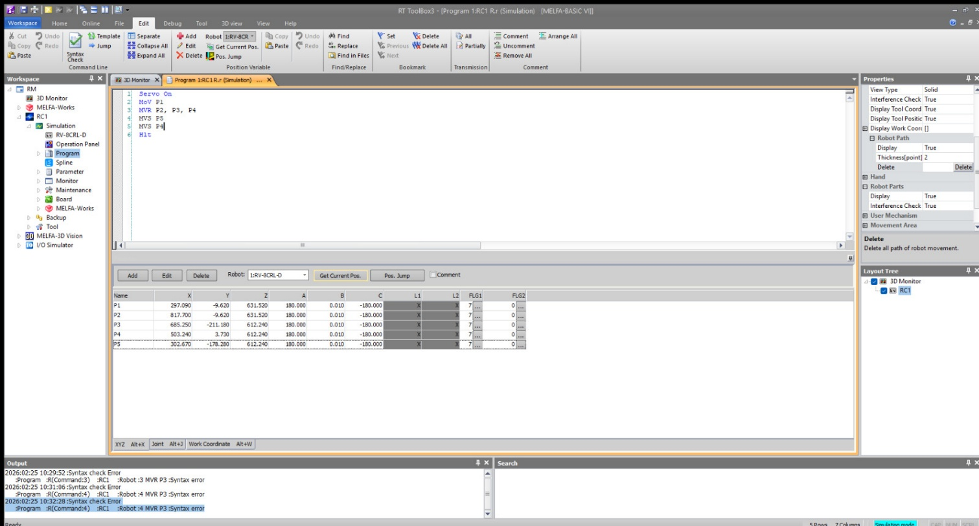
Figure 1: Source Code for Robotic Interpolation and Trajectory Planning (R Letter).

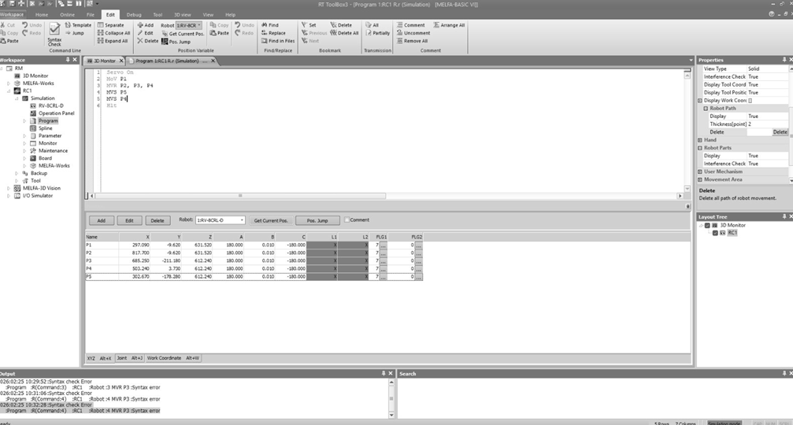
Figure 2: Defined Workspace Coordinates for Trajectory Synthesis.
Expt No:  01 | ALPHANUMERIC AND SYMBOLIC TRAJECTORY SYNTHESIS
Date:
28 / 01 /2026

- AIM:
To design and implement a high-precision robotic trajectory for the synthesis of alphanumeric or symbolic contours through the orchestration of linear and circular interpolation techniques on a 6-axis industrial manipulator.

- APPARATUS REQUIRED:
  - Manipulator System: Mitsubishi RV-8CRL-D 6-axis industrial robot.
  - Control Hardware: CR800-D series dedicated robot controller.
  - Software Suite: RT ToolBox3 integrated engineering environment.
  - End-of-Arm Tooling : Precision drawing effector configured within the tool coordinate system.
  - Infrastructure: Solid installation platform and standard TCP/IP or standard USB communication interface.

- THEORY:
Trajectory generation for planar symbolic mapping requires the mathematical decomposition of characters into primitive geometric segments.
- Core Principle:
The robot Tool Center Point (TCP) is commanded to follow a continuous path synthesized from individual motion commands that dictate both spatial orientation and execution velocity.
- Working Mechanism:
  - Linear Interpolation (Mvs): The system calculates a straight-line motion vector between two spatial coordinates, maintaining constant velocity. This is essential for rendering the rigid segments of characters (e.g., 'L', 'H').
  - Circular Interpolation (Mvc / Mvr): Utilizing a three-point reference logic (Start, Auxiliary/Passing, and End), the controller mathematically generates the rotational arcs required for curved characters (e.g., 'O', 'S').
  - Continuous Path Control (Cnt): By invoking Cnt 1, the controller bypasses deceleration at intermediate via-points. This ensures fluid motion blending across trajectory nodes, thereby preserving geometric integrity and minimizing cycle time.

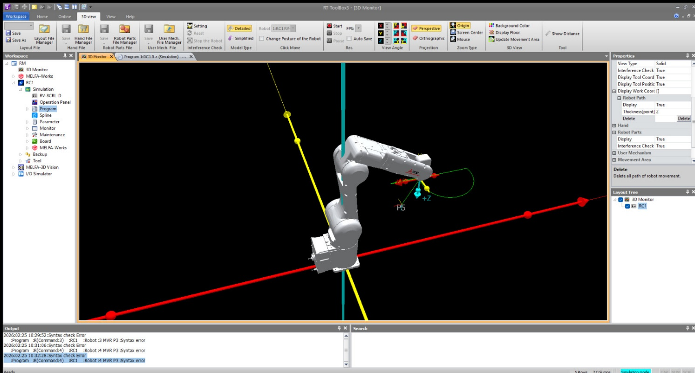
Figure 3: Simulated Kinematic Trajectory in the RT ToolBox3 3D Monitor.

- PROCEDURE:
- Setup & Connections:
Establish the communication link between the engineering workstation and the CR800-D controller. Perform an origin data verification to ensure absolute axis calibration.
- Algorithm & Logic:
  - Initialize servos and designate the drawing tool parameters.
  - Execute a joint-interpolated move to a stabilized approach height directly above the initial character coordinate.
  - Sequentially trigger interpolation commands (Mvs for straight vectors, Mvc for curves) to construct the symbol.
  - Incorporate temporal delays (Dly) between active strokes to allow for mechanical vibration settling.
  - Terminate the cycle by retreating to a verified safe home position (phome).
- Execution Steps:
  - Load the synthesized logic into the RT ToolBox3 program editor.
  - Perform a Step Run in manual mode at reduced override speed to validate the path and ensure collision avoidance.
  - Transition the controller to Automatic mode for high-speed trajectory execution.
- Observation Instructions:
Utilize the RT ToolBox3 Oscillograph tool to analyze motor current commands and axis load levels, specifically noting load spikes during high-speed curve transitions.

- RESULT AND OBSERVATION:
The system achieved accurate contour synthesis with smooth motion and consistent precision throughout the operation, as verified by faculty evaluation.

